**R Code for Examples in the book**

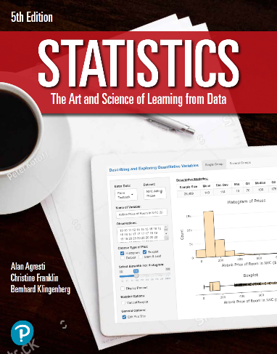

***“Statistics: The Art and Science of Learning from Data”***

**by Agresti, Franklin and Klingenberg, 5th edition**

**Chapter 15**

**Example 8: GRE Test Scores – Wilcoxon Signed-Rank Test**

## Reading in data

before <- c(2.5, 4, 1.5)  
after <- c(3, 3.5, 3)

## To perform a Wilcoxon signed-rank test

wilcox.test(before, after, paired = TRUE, alternative = 'greater')

## Warning in wilcox.test.default(before, after, paired = TRUE, alternative =  
## "greater"): cannot compute exact p-value with ties

##   
## Wilcoxon signed rank test with continuity correction  
##   
## data: before and after  
## V = 1.5, p-value = 0.8618  
## alternative hypothesis: true location shift is greater than 0